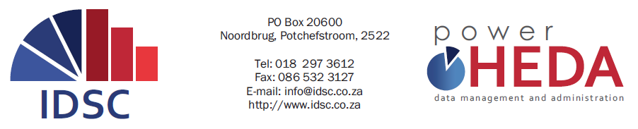

2015 PowerHEDA USER GROUP
28 – 30 October 2015

REGISTRATION FORM

IMPORTANT INFORMATION
- Please fill in the appropriate details to register for the 2015 User Group, and e-mail to corne@idsc.co.za
- A maximum of two persons per institution (free of charge) – additional persons and non-HEDA clients are welcome to attend the Workshop at a cost of R1300.00 (VAT excluded) per person.
- We encourage you to book your accommodation as soon as possible at the PUK Sport Village
on 018 299 2117 (Accommodation is for your own/institution account).
- The evening dinner on Thursday, 29 October will be held at Christa Galli, R501 Thabo Mbeki Rd, Potchefstroom.
PERSONAL INFORMATION
Title | Mr. |  | Ms. |  | Dr. |  |  | Prof.
First Name |  |  |  | Last Name
Preferred name
(as printed on name card)
Institution
Tel (office) |  |  |  | Fax
Cell phone
E-mail
Dietary requirements |  | Halaal |  |  |  | Vegetarian
 |  | Other (Please specify)

USERGROUP ACTIVITIES YOU PLAN TO ATTEND
 | Day 1: 2015 User Group | Wednesday, 28 October 2015 | @ Sports Village
 | Cocktail Function | Wednesday, 28 October 2015 | @ Sports Village
 | Day 2: 2015 User Group | Thursday, 29 October 2015 | @ Sports Village
 | Formal Dinner | Thursday, 29 October 2015 | @ Christa Galli
 | Day 3: 2015 User Group | Friday, 30 October 2015 | @ Sports Village

PAYMENT
Please forward me an invoice for payment (additional person or a non-HEDA client)

